SOAP (Simple Object Access Protocol)

Its a message protocol that enables the distributed elements of an application to communicate (позволяет распределенным элементам приложения обмениваться данными).or in other words is a definition of how web services talk to each other or talk to client applications that invoke them.

In today’s world, there is huge number of applications which are built on different programming languages. Exchanging data between applications is crucial in today’s networked world. But data exchange between these applications would be complex. So will be the complexity of the code to accomplish this data exchange. One of the methods used to combat this complexity is to use XML (Extensible Markup Language) as the intermediate language for exchanging data between applications.Every programming language can understand the XML markup language. Hence, (следовательно) XML was used as the underlying medium for data exchange (базовой среды для обмена данными).SOAP was designed to work with XML over HTTP and have some sort of specification which could be used across all applications.

But there are no standard specifications on use of XML across all programming languages for data exchange. That is where SOAP software comes in.

SOAP can be carried over a variety of standard protocols, including the web-related Hypertext Transfer Protocol (HTTP).SOAP was developed as an intermediate language for applications that have different programming languages, enabling these applications to communicate with each other over the internet.

Simple Object Access Protocol, as a specification, defines SOAP messages that are sent to web services and client applications. SOAP messages are XML documents that are comprised (состоит) of the following three basic building blocks:

1)-The SOAP Envelope encapsulates all the data in a message and identifies the XML document as a SOAP message.(в общем это и есть само сообщение, или контейнер в котором и расположено собственно говоря всё сообщение), The SOAP envelope indicates the start and the end of the message so that the receiver knows when an entire message has been received. The SOAP envelope solves the problem of knowing when you are done receiving a message and are ready to process it. The SOAP envelope is therefore basically a packaging mechanism.

-Envelope is a mandatory part of SOAP message.

-Every Envelope element must contain exactly one Body element.

-If an Envelope contains a Header element, it must contain no more than one, and it must appear as the first child of the Envelope, before the Body.

-The envelope changes when SOAP versions change.

-The SOAP envelope is specified using the ENV namespace prefix and the Envelope element.

2)-The Header element contains additional information about the SOAP message. This information could be authentication credentials (учетные данные при аутентификации), for example, which are used by the calling application, It can also contain the definition of complex types which could be used in the SOAP message. By default, the SOAP message can contain parameters which could be of simple types such as strings and numbers, but can also be a complex object type. The optional Header element offers a flexible framework for specifying additional application-level requirements. For example, the Header element can be used to specify a digital signature for password-protected services. Likewise, it can be used to specify an account number for pay-per-use SOAP services.

**A SOAP Header can have the following two attributes −**

A) - **Actor** attribute

The SOAP protocol defines a message path as a list of SOAP service nodes. Each of these intermediate nodes can perform some processing and then forward the message to the next node in the chain. By setting the Actor attribute, the client can specify the recipient of the SOAP header.

B) - **MustUnderstand** attribute

It indicates whether a Header element is optional or mandatory. If set to true, the recipient must understand and process the Header attribute according to its defined semantics, or return a fault.

**The following example shows how to use a Header in a SOAP message.**

**<?xml version = "1.0"?> <!--**

**<SOAP-ENV:Envelope**

**xmlns:SOAP-ENV = " http://www.w3.org/2001/12/soap-envelope"**

**SOAP-ENV:encodingStyle = " http://www.w3.org/2001/12/soap-encoding">**

**<SOAP-ENV:Header>**

**<t:Transaction**

**xmlns:t = "http://www.tutorialspoint.com/transaction/"**

**SOAP-ENV:mustUnderstand = "true">5**

**</t:Transaction>**

**</SOAP-ENV:Header>**

**...**

**...**

**</SOAP-ENV:Envelope>**

3)-The Body element includes the details of the actual message that need to be sent from the web service to the calling application. This data includes call and response information. The SOAP body is a mandatory element that contains the application-defined XML data being exchanged in the SOAP message.

The body is defined as a child element of the envelope, and the semantics for the body are defined in the associated SOAP schema.

The body contains mandatory information intended for the ultimate receiver of the message. For example −

<?xml version = "1.0"?>

<SOAP-ENV:Envelope>

........

<SOAP-ENV:Body>

<m:GetQuotation xmlns:m = "http://www.tp.com/Quotation">

<m:Item>Computers</m:Item>

</m:GetQuotation>

</SOAP-ENV:Body>

</SOAP-ENV:Envelope>

The example above requests a quotation of computer sets.(предложение комплектов компьютеров) Note that the m:GetQuotation and the Item elements above are application-specific elements. They are not a part of the SOAP standard.

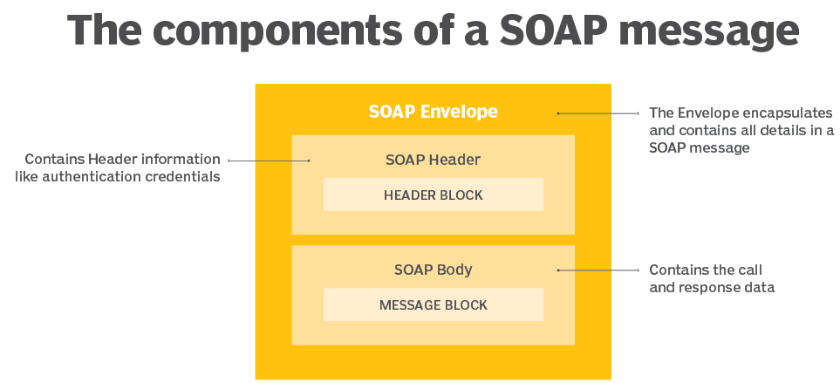

**How does SOAP work?**

First, a request for a service is generated by a client using an XML document. Next, a SOAP client sends the XML document to a SOAP server. When the server receives the SOAP message, it sends the message as a service invocation to the requested server-side application (сервер перенаправляет сообщение запрошенному приложению на стороне сервера). A response containing the requested parameters, return values and data for the client is returned first to the SOAP request handler and then to the requesting client (возвращается сначала обработчику запроса SOAP, а затем запрашивающему клиенту). Both SOAP requests and responses are transported using Hypertext Transfer Protocol Secure (HTTPS) or a similar protocol like HTTP.

**the general structure of a SOAP message**

<?xml version = "1.0"?>

<SOAP-ENV:Envelope xmlns:SOAP-ENV = "http://www.w3.org/2001/12/soap-envelope"

SOAP-ENV:encodingStyle = "http://www.w3.org/2001/12/soap-encoding">

<SOAP-ENV:Header>

...

...

</SOAP-ENV:Header>

<SOAP-ENV:Body>

...

...

<SOAP-ENV:Fault>

...

...

</SOAP-ENV:Fault>

...

</SOAP-ENV:Body>

</SOAP_ENV:Envelope>

simple SOAP message structure:

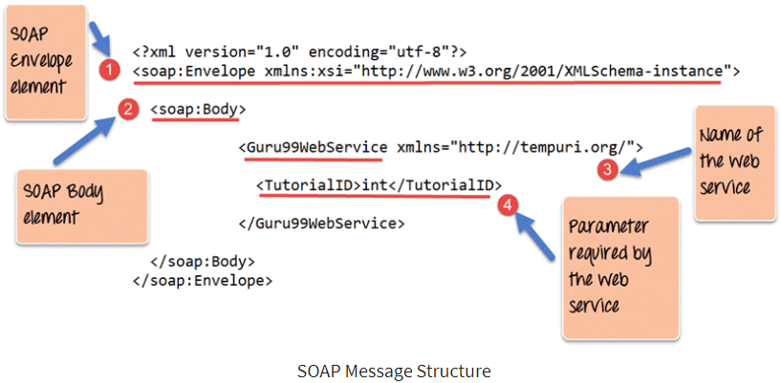

1) the first part of the SOAP message is the envelope element which is used to encapsulate the entire SOAP message.

2) The next element is the SOAP body which contains the details of the actual message.

3) Our message contains a web service which has the name of “Guru99WebService”.

4) The “Guru99Webservice” accepts a parameter of the type ‘int’ and has the name of TutorialID.

**ещё Пример SOAP message:**

Content-Type: application/soap+xml

<env:Envelope xmlns:env="http://www.w3.org/2003/05/soap-envelope">

<env:Header>

<m:GetLastTradePrice xmlns:m="Some-URI" />

</env:Header>

<env:Body>

<symbol xmlns:p="Some-URI" >DIS</symbol>

</env:Body>

</env:Envelope>

—---------------------------------------------------------------------------------------------------------------------------------------------------------

SOAP schema.?

Normally, the application also defines a schema to contain semantics associated with the request and response elements.

**—-----------------------------------------------------------------------------------------------------------------------------------------------------------**

SOAP with HTTP POST

The following example illustrates the use of a SOAP message within an HTTP POST operation, which sends the message to the server. It shows the namespaces for the envelope schema definition and for the schema definition of the encoding rules. The **OrderEntry** reference in the HTTP header is the name of the program to be invoked at the tutorialspoint.com website.

POST /**OrderEntry** HTTP/1.1

Host: www.tutorialspoint.com

Content-Type: application/soap; charset = "utf-8"

Content-Length: nnnn <!--всё, что с верху это HTTP bindings (привязки)

<?xml version = "1.0"?>

<SOAP-ENV:Envelope

xmlns:SOAP-ENV = "http://www.w3.org/2001/12/soap-envelope"

SOAP-ENV:encodingStyle = " http://www.w3.org/2001/12/soap-encoding">

...

Message information goes here

...

</SOAP-ENV:Envelope>

!NOTE − The HTTP binding specifies the location of the service.

—-----------------------------------------------------------------------------------------------------------------------------------------------------------

**SOAP - Fault**

If an error occurs during processing, the response to a SOAP message is a SOAP fault element in the body of the message, and the fault is returned to the sender of the SOAP message.

The SOAP fault mechanism returns specific information about the error, including a predefined code, a description, and the address of the SOAP processor that generated the fault.

Points to Note about fault:

- A SOAP message can carry only one fault block.

- Fault is an optional part of a SOAP message.

- For HTTP binding, a successful response is linked to the 200 to 299 range of status codes.

- SOAP Fault is linked to the 500 to 599 range of status codes.

**Sub-elements of Fault**

The SOAP Fault has the following sub elements −

1)- <faultCode> It is a text code used to indicate a class of errors. See the next Table for a listing of predefined fault codes.

2)- <faultString> It is a text message explaining the error.

3)- <faultActor> It is a text string indicating who caused the fault. It is useful if the SOAP message travels through several nodes in the SOAP message path, and the client needs to know which node caused the error. A node that does not act as the ultimate destination must include a faultActor element.

4)- <detail> It is an element used to carry application-specific error messages. The detail element can contain child elements called detail entries.

SOAP Fault Codes

The faultCode values defined below must be used in the faultcode element while describing faults.

1)- SOAP-ENV:VersionMismatch.

Found an invalid namespace for the SOAP Envelope element.

2)- SOAP-ENV:MustUnderstand

An immediate child element of the Header element, with the mustUnderstand attribute set to "1", was not understood.

3)-SOAP-ENV:Client

The message was incorrectly formed or contained incorrect information.

4)- SOAP-ENV:Server

There was a problem with the server, so the message could not proceed.

SOAP Fault Example

The following code is a sample Fault. The client has requested a method named ValidateCreditCard, but the service does not support such a method. This represents a client request error, and the server returns the following SOAP response −

<?xml version = '1.0' encoding = 'UTF-8'?>

<SOAP-ENV:Envelope

xmlns:SOAP-ENV = "http://schemas.xmlsoap.org/soap/envelope/"

xmlns:xsi = "http://www.w3.org/1999/XMLSchema-instance"

xmlns:xsd = "http://www.w3.org/1999/XMLSchema">

<SOAP-ENV:Body>

<SOAP-ENV:Fault>

<faultcode xsi:type = "xsd:string">SOAP-ENV:Client</faultcode> ← **смотрим чё за код ошибки**

<faultstring xsi:type = "xsd:string">

Failed to locate method (ValidateCreditCard) in class (examplesCreditCard) at

/usr/local/ActivePerl-5.6/lib/site_perl/5.6.0/SOAP/Lite.pm line 1555.

</faultstring>

</SOAP-ENV:Fault>

</SOAP-ENV:Body>

</SOAP-ENV:Envelope>

**SOAP - Encoding**

SOAP includes a built-in set of rules for encoding data types. It enables the SOAP message to indicate specific data types, such as integers, floats, doubles, or arrays.

+SOAP data types are divided into two broad categories − scalar types and compound types.

+Scalar types contain exactly one value such as a last name, price, or product description.

+Compound (составные) types contain multiple values such as a purchase order or a list of stock quotes.

+Compound types are further subdivided into arrays and structs.

+The encoding style for a SOAP message is set via the SOAP-ENV:encodingStyle attribute.

+Latest SOAP specification adopts all the built-in types defined by XML Schema. Still, SOAP maintains its own convention for defining constructs not standardized by XML Schema, such as arrays and references.

HTTP remains the most popular SOAP transport protocol.

Quite logically, SOAP requests are sent via an HTTP request and SOAP responses are returned within the content of the HTTP response. While SOAP requests can be sent via an HTTP GET, the specification includes details on HTTP POST only.

Additionally, both HTTP requests and responses are required to set their content type to **text/xml**.

The SOAP specification mandates that the client must provide a SOAPAction header, but the actual value of the SOAPAction header is dependent on the SOAP server implementation.

For example, to access the AltaVista BabelFish Translation service, hosted by XMethods, you must specify the following as a SOAPAction header.

Even if the server does not require a full SOAPAction header, the client must specify an empty string ("") or a null value. For example −

SOAPAction: ""

SOAPAction:

Обьяснения другими источниками

**SOAP**

They are just ways of doing API.<--непонятно, уже понятно имеется ввиду что это способ организаци API, и обратно перечитываю - это скорее 2 вида HTTP.

Web services (API) that go over internet, use HTTP, **SOAP and REST is just 2 separate ways to form that HTTP request and HTTP response.**

**SOAP-**simple object access protocol. And it's not simple, it's just a subjective term.Basically its a way to access a web service (API) by following rules(protokols). Again! We access the API using HTTP!!!

So SOAP are rules (protokols) **to form** the HTTP request and HTTP response.

Every API that uses the SOAP has a **WSDL** (**W**eb **S**ervices **D**escription **L**anguage), this is XML and

It describes what you can send and get to/from SOAP API (the Web Service).

ниже фрагмент **WSDL** файла **из** API где элементом является описание тега, а атрибут name является именем, т.е. то как должен называться тег в xml в запросе клиента

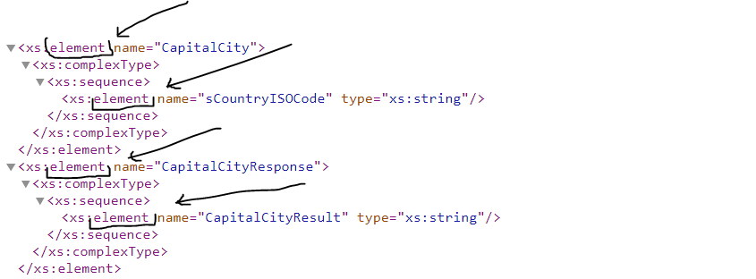

As you remember in HTTP there are 4 parts, according to a SOAP, when we generate HTTP it has : **1)-in a start line** we always have to use:

**1)- method POST**. The reason why is not because SOAP always create information, but because the method is not used, this is just a placeholder(заполнитель).

**2)- WSDL location**

**3)-HTTP version**

Example: Start Line Post WSDL HTTP version

**2)- in a headers line** we have to have header Content-Type text/xml. In another words we always need to have XML in the body.Because SOAP works only with XML.

**3)**-**blank line** - nothing, its just for separating HTTP headers from the body.

**4)**-**body** - as we already know from header line, we have to have XML included in it. (probably SOAP use only XML). And XML formed using the web services (API) description from **WSDL.**

Every time we are creating a XML in the body of HTTP using SOAP, we have to include something that is called **soap Envelope** wich contains:Namespaces, xsd(пока не понятно что это), тэги или по другому элементы(название этих тегов описано в WSDL).

-**Namespaces**. XML Namespaces provide a method to avoid element (имеется ввиду названия тегов) name conflicts. In XML, element names (by saying element names means tag names) are defined by the developer. This often results in a conflict when trying to mix XML documents from different XML applications.

This XML carries **HTML** table information:

<table>

<tr>

<td>Apples</td>

<td>Bananas</td>

</tr>

</table>

This XML carries **information about a table** (a piece of furniture):

<table>

<name>African Coffee Table</name>

<width>80</width>

<length>120</length>

</table>

If these XML fragments were added together, there would be a name conflict. Both contain a <table> element, but the elements have different content and meaning. A user or an XML application will not know how to handle these differences.

Name conflicts in XML can easily be avoided using a name prefix. This XML carries information about an HTML table, and a piece of furniture:

<h:table>

<h:tr>

<h:td>Apples</h:td>

<h:td>Bananas</h:td>

</h:tr>

</h:table>

<f:table>

<f:name>African Coffee Table</f:name>

<f:width>80</f:width>

<f:length>120</f:length>

</f:table>

In the example above, there will be no conflict because the two <table> elements have different names because of the prefix.

When using prefixes in XML, a **namespace** for the prefix must be defined.

The namespace can be defined by an **xmlns** attribute in the start tag of an element.(n.s.- means namespace)

The namespace declaration has the following syntax. **xmlns:prefix="URI"**.интересно а префиксы можно использовать какие хочеш?

<root>

<h:table xmlns:h="<http://www.w3.org/TR/html4/>"> //**xmlns** attribute in the start tag of an element.

<h:tr>

<h:td>Apples</h:td>

<h:td>Bananas</h:td>

</h:tr>

</h:table>

<f:table xmlns:f="https://www.w3schools.com/furniture">

<f:name>African Coffee Table</f:name>

<f:width>80</f:width>

<f:length>120</f:length>

</f:table>

</root>

The xmlns attribute in the first <table> element gives the h: prefix a qualified namespace.

The xmlns attribute in the second <table> element gives the f: prefix a qualified namespace.

Namespaces can also be declared in the XML root element:

<root xmlns:h="<http://www.w3.org/TR/html4/>" //declaration of namespace in root

xmlns:f="https://www.w3schools.com/furniture">

<h:table>

<h:tr>

<h:td>Apples</h:td>

<h:td>Bananas</h:td>

</h:tr>

</h:table>

<f:table>

<f:name>African Coffee Table</f:name>

<f:width>80</f:width>

<f:length>120</f:length>

</f:table>

</root>

Note: The namespace URI is not used by the parser to look up information.

The purpose of using an URI is to give the namespace a unique name.

**!!!** Below is example of SOAP body, that contains mandatory element <soap:Envelope> which contains…

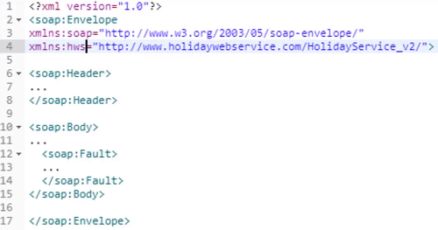

SOAP was created by the same organization that created XML (they use XML for the WSDL and they use XML in the body)

В ОБЩЕМ, что я понял, когда API является SOAP сервисом, то у него есть WSDL - описание всего того что умеет эта API и как к ней формировать запросы и в какой форме приходят риспонсы. Тестировать SOAP можно в Postman или SOAP UI. Идея в том чтобы используя WSDL правильно (корректно) сформулировать риквест и получив риспонс от API, сверить его с документацией на соответствие.

A cache is where something is kept in memory. For example when you request something from the server. and gat the result you can keep it in your cache in case if some time afterwards you again makes the same request you don't need to go to the server you can get that response from the cache. The reason why it has to do with REST is because of get function (GET method). If you have the result in your cache, you don't need to go to the server again.